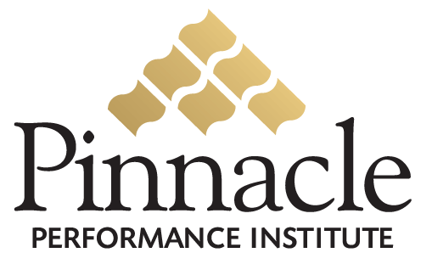


Close the Gap
between
Vision & Execution

Expose Reality…
and Act Upon It

Online Performance

Enhancement Solution

Execution
is exposing reality…
and acting upon it.

Measure
Strengths and Weaknesses

Build
Confidence and Competence
Communicate
Throughout the Entire Organization
clearly convey
your leadership vision,
the team experience, and
the customer relationship





Did You Know…

- Only 48% of workers say their organization has a clear strategic direction and only 37% understand the reason for the strategic direction.
- Only 44% of workers say their organization has clearly communicated its most important goals.
- Only 54% of workers say they clearly understand what they are supposed to do to help their organization’s goals.
- Only 15% of workers could actually identify their organization’s top three goals.
According to studies by FranklinCovey in March 2004 of 12,182 workers and another of 26,500 workers.
Your Pinnacle Performance Enhancement Solution
will significantly increase your retention
through total team involvement.
Chinese Proverb:
Tell me and I will forget;
Show me and I may remember;
Involve me and I understand.

You Retain
10% of what you hear
25% of what you see
90% of what you do

What’s It Worth?
Would you invest 2% in your team for a 20% - 50% return
in productivity and customer satisfaction?

Close the Gap between Vision & Execution
Expose Reality… and Act Upon It

Business Assessments:How well is your organization defining, communicating and accomplishing its objectives?
Professional Assessments:How well equipped is your team with the hard and soft skills to excel at their jobs?
Performance Prescriptions: What are the specific training needs of each individual on your team?
Dynamic Surveys: Are you getting direct feedback from all members of your team and your customers?
Company-Specific Learning:Your team members will learn from custom courses on your products, sales techniques, policies and procedures, etc.
Pinnacle Course Catalog:Your team members will learn from hundreds of public courses by trainers nation-wide.
Specific Training Groups: You can define recommended and required custom and public courses for your different team member departments and projects.
Certification Testing: You can define custom tests for team member certification and recognition.
Multimedia Communication:You can produce near real-time communication including new product rollouts, company announcements, conventions, management messages, recognition, etc.
Communication Forums:You and your team members can communicate with each other on online conference rooms and discussion boards.
Team Communication: Team members can submit ideas to you in electronic 2-way suggestion boxes and dynamic surveys.
Management Reports: You can analyze important performance information through powerful management reports.
Company Branded Solution: Customized with your company name, graphics, logo, colors and certificates.
Company Specific Pages: Customized with your company pages editable by you at any time with no technical skills.
Company Specific Courses: Customized company courses for your internal training needs editable by you at any time with no technical skills.
Department Specific Training: Recommended and required courses for your different team member departments.

No Setup Fees: There are no upfront setup or maintenance fees.
No Long-Term Contract: There is no obligation to continue if you do not receive value from the Pinnacle Solution.
No Technology: Pinnacle manages the technology behind the scenes for you, so that you can focus on your business.
No Hidden Charges – One Simple Fee: All services are included for a small monthly investment per user.

Pinnacle Multi-directional communication

Pinnacle customizable solution

Pinnacle affordable solution

Pinnacle Performance METRICs

Pinnacle confidence and competence

